EXPERIMENT – 3
Identifying interaction design and functional layout. Practical implementation of interaction design and functional layouts

Submitted by:
Name: Pavan Kalyan K
Reg No: 23MIS0563

Team Details : 1) Pavan Kalyan K - 23MIS0563
2) Surya R - 23MIS0592
3) Mohanakumar L - 23MIS0516

Title : AI-Powered Smart Travel Planner
Chosen Screen for Documentation : Destination Search

1. Aim

To identify user requirements for the Destination Search feature of an AI-Powered Smart Travel Planner, design an interaction prototype based on those requirements, and implement it with consistent interaction patterns, button placement, wording, and colour scheme to help users search and explore travel destinations efficiently.

2. Objectives

- Understand the interaction design principles involved in a destination search interface.
- Translate user requirements into an interactive prototype for the Destination Search module.
- Maintain consistency in navigation, button placement, labels, icons, and colour scheme throughout the interaction.
- Incorporate AI-powered destination recommendations with clear confidence indicators.
- Build an interface that supports an intuitive and predictable user experience.

3. Theory

3.1 Interaction Design

Interaction Design focuses on designing meaningful communication between users and digital systems. It defines how users interact with interface elements such as search bars, filters, buttons, recommendation cards, and navigation components. A well-designed interaction enables users to complete their tasks with minimal effort while receiving immediate and understandable feedback.

3.2 Functional Layout

A functional layout organizes interface elements according to their importance and frequency of use. In the Destination Search page, the search bar is positioned prominently, followed by destination categories, AI recommendations, and filtering options. This arrangement helps users quickly locate destinations while minimizing unnecessary navigation.

3.3 Consistency Principles

Consistency improves usability by ensuring interface elements behave similarly throughout the application.
Three consistency principles applied are:
- Placement Consistency – Navigation bar, search field, filter controls, and recommendation cards remain in fixed positions.
- Wording Consistency – Labels such as "Search Destination", "Explore", "Filter", and "View Details" remain unchanged throughout the module.
- Colour Consistency – Blue is consistently used for navigation and primary actions, while green confidence badges indicate highly reliable AI recommendations.

3.4 Mental Model

A user's mental model develops through repeated interaction with familiar interface patterns. By maintaining consistent navigation, search interactions, recommendation cards, and filter layouts, users can quickly predict how the interface behaves, reducing learning time and improving efficiency.

4. Software / Tools Used

- HTML5, CSS3, and JavaScript (for the interactive prototype)
- Any browser to run the prototype (Chrome / Edge / Firefox)
- (Optional) A wireframing tool such as Figma, Balsamiq

5. Activity 1 – Design and Prototype the Interaction
5.1 Step 1 – Identify User Requirements
# | User Requirement | Screen / Interaction it maps to
1 | The user should be able to search destinations using keywords. | Destination Search
2 | The user should receive AI-powered destination recommendations. | AI Recommendation Cards
3 | The user should filter destinations by country, budget, season, and travel type. | Filter Panel
4 | The user should clearly understand the AI's confidence in each recommendation. | Destination Recommendation Cards
5 | The user should view detailed information about a selected destination. | Destination Details

5.2 Step 2 – Map the Screen Flow
Before designing the interface, the interaction flow is planned to ensure smooth navigation between related screens.
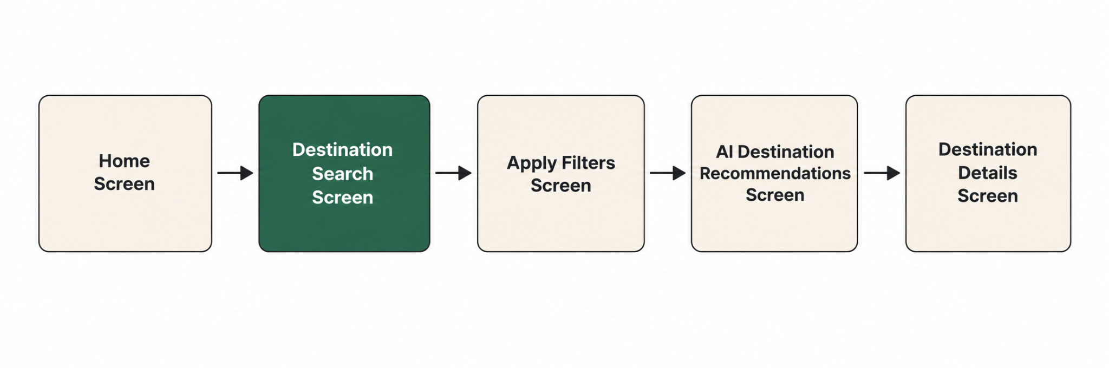

5.3 Step 3 – Build the Prototype

The prototype is implemented as an interactive design consisting of interconnected screens related to destination discovery.
The interface includes:
- A persistent navigation bar for easy access to Home, Trips, Bookings, and Profile.
- A prominent search bar positioned at the top of the screen.
- AI-generated destination recommendation cards displaying destination images, estimated travel cost, weather summary, and confidence indicators.
- A collapsible filter panel allowing users to refine search results.
- Consistent destination cards with identical layouts across all recommendations.

6. Activity 2 – Apply and Verify Consistency

Activity 2 was implemented by defining common interaction rules and maintaining them throughout the Destination Search workflow.

6.1 Consistency Rules Applied

Rule | Where it appears | How it was kept consistent
Search Bar Placement | Destination Search, AI Recommendations | Search bar always remains at the top of the page.
Button Placement | Search, Filter, View Details | Primary actions consistently appear below the search section.
Label Wording | Search, Filters, Recommendation Cards | Labels such as "Search Destination", "Apply Filters", and "View Details" remain unchanged.
Colour Scheme | Entire module | Blue is reserved for primary actions, green indicates high AI confidence, and orange represents medium confidence.
AI Confidence Badge | Recommendation Cards | Confidence indicators use the same badge style, colours, and placement across every recommendation card.

6.2 How this Builds an Accurate Mental Model

The interface follows predictable interaction patterns throughout the destination discovery process. Users learn the search and filtering workflow during their first interaction and can confidently repeat the same process without additional guidance.
The consistent placement of search controls, recommendation cards, and confidence indicators enables users to focus on selecting destinations rather than learning new interface behaviours. This predictable experience supports the overall usability goals of the application.

7. Output / Result

The completed prototype successfully demonstrates the Destination Search feature of the AI-Powered Smart Travel Planner. Users can search destinations, refine results using filters, receive AI-generated recommendations with visible confidence levels, and navigate to destination details through a consistent and intuitive interaction flow.

7.1 Self-Evaluation Checklist
Check | Result
Is the search bar consistently positioned? | Yes - top section on all related screens
Are primary buttons placed consistently? | Yes - below the search section on every screen
Do recommendation cards use consistent layouts? | Yes - identical card structure and spacing
Are AI confidence indicators displayed consistently? | Yes - same badge style and position throughout
Can users predict the next interaction after searching? | Yes - the search → filter → recommendations → details flow remains consistent

